Implementing a GUI for the Gourmet Coffee System (Part I)

Prerequisites, Goals, and Outcomes
Prerequisites: Before you begin this exercise, you need mastery of the following:
- Graphical user interface (GUI)
  - Knowledge of Swing components and containers
Goals: Reinforce your ability to create a GUI using Swing
Outcomes: You will master the following skills:
- Produce applications that use a Swing GUI

Background
In this assignment, you will create a GUI that displays the Gourmet Coffee System's product catalog. Part of the work has been done for you and is provided in the student archive. You will complete the code that creates a graphical presentation of the product details.

Description
Class CatalogGUI lets the user display the product details of every product in the gourmet coffee store's product catalog. This simple GUI contains the following components:
- a JList that displays the product code of every product in the catalog
- a JPanel that presents product details
- a JTextArea that serves as a status area
To examine the details of a particular product, the user selects the product code in the list. The application responds by displaying the product details in the JPanel and a status message in the JTextArea.
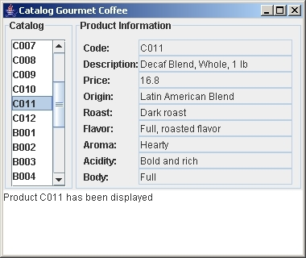
Figure 1 Execution of CatalogGUI
The following class diagram highlights the classes used to implement the GUI:
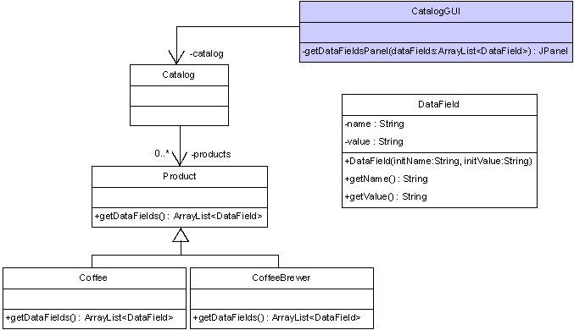
Figure 2 Portion of Gourmet Coffee System class diagram
Class CatalogGUI instantiates the Swing components, arranges the components in a window, and handles the events generated by the list. In this assignment, you will implement the method getDataFieldsPanel that returns a JPanel displaying the product details. An incomplete implementation of CatalogGUI is provided in the student archive.
Class DataField contains a name/value pair that represents a single attribute that is stored within an object. A complete implementation of DataField is provided in the student archive.
Classes Product, Coffee, and CoffeeBrewer have been enhanced to add a method called getDataFields that returns an ArrayList of DataField objects with the product details:
- In class Product, the method getDataFields returns an ArrayList with DataField objects for the attributes "code", "description" and "price".
- In class Coffee, the method getDataFields returns an ArrayList with DataField objects for the attributes "code", "description", "price", "origin", "roast", "flavor", "aroma", "acidity" and "body".
- In class CoffeeBrewer, the method getDataFields returns an ArrayList with DataField for the attributes "code", "description", "price", "model", "waterSupply" and "numberOfCups".
A complete implementation of classes Product, Coffee, and CoffeeBrewer are provided in the student archive.
Class Catalog has been enhanced: it now contains a method called getCodes that returns an array of product codes (all the product codes in the product catalog) which CatalogGUI uses to populate the JList. A complete implementation of Catalog is provided in the student archive.

Files
The following files are needed to complete this assignment:
- student-files.zip — Download this file. This archive contains the following:
  - Class files
    - Product.class
    - Coffee.class
    - CoffeeBrewer.class
    - Catalog.class
    - CatalogLoader.class
    - FileCatalogLoader.class
    - DataFormatException.class
    - DataField.class
  - Documentation
    - Product.html
    - Coffee.html
    - CoffeeBrewer.html
    - Catalog.html
    - CatalogLoader.html
    - FileCatalogLoader.html
    - DataFormatException.html
    - DataField.html
  - Java files
    - CatalogGUI.java— a complete implementation
  - Data files for the test driver
    - catalog.dat — a file with product information for every product in the product catalog

Tasks
The following steps will guide you through this assignment. Work incrementally and test each increment. Follow Sun's code conventions. Save often.
- Extract the files by issuing the following command at the command prompt:
C:\>unzip student-files.zip
- Then, complete the implementation of the method getDataFieldsPanel in the class CatalogGUI.
private JPanel getDataFieldsPanel(ArrayList<DataField> dataFields) — Returns a reference to a JPanel object that shows the names and values of the DataField objects stored in the parameter dataFields:
    - For a coffee product, dataFields contains nine DataField objects with the names: "Code", "Description", "Price", "Origin", "Roast", "Flavor", "Aroma", "Acidity" and "Body".
    - For a coffee brewer, dataFields contains six DataField objects with the names: "Code", "Description", "Price", "Model", "Water supply" and "Number of cups".
    - For a generic product, dataFields contains three DataField objects with the names: "Code", "Description" and "Price".
For each DataField object stored in dataFields, the JPanel should contain a JLabel object with the name of the attribute and an uneditable JTextField object with the value of the attribute. Use the JPanel layering technique to build the JPanel. The arrangement of the JPanel need not match Figure 1 exactly; any well-organized presentation of the attributes will be acceptable.
- Finally, compile and execute the class CatalogGUI.

Submission
Upon completion, submit only the following.
- CatalogGUI.java

